TITLE OF THE PAPER (Arial 20, bold, left)

Name of the author(s) (Arial 11, regular, left-aligned)
Institution (Arial 7, left-aligned)
E-mail: your@email.edu
Contact phone
Adress

Summary (Arial 9, bold, left-aligned)
Summary (max 250 words, Arial 9, regular, justify, single line spacing)
Key words: 3-5 (Arial 9, bold)

1. INTRODUCTION (Arial 11, bold, uppercase, left-aligned)
Normal text of the paper (Arial 9, justify, single line spacing)

1.1. Model and Data (Arial 10, bold, lowercase, left-aligned)
Normal text of the paper (Arial 9, justify, single line spacing)

    - Model and Data (Arial 9, bold, lowercase, left-aligned)
Normal text of the paper (Arial 9, justify, single line spacing)

2. FORMAT GUIDELINES
Tables, diagrams, images, and graphs have to be informative (numbered sequentially, labelled, with source and, if necessary, with legend). The title has to be above the table, the source below, while the titles of images, graphs and diagrams have to be labelled below.

Table 1 Title of the Table (Arial, 9, center)
 | 1998. | 1999. | 2000. | 2001. | 2002.
Poland
Russia
Sweden
Source: Arial 8, regular, left-aligned

Source: Arial 8, regular, left-aligned
Graph 1 Title of the Graph (Arial, 9, center)

Images should be prepared and submitted in JPEG or TIFF format (coloured, 300 dpi resolution, and 600 dpi greyscale). Images have to be clear and contrasting.

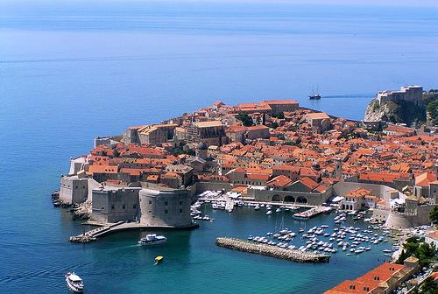

Source: Arial 8, regular, left-aligned
Figure 1 Title of the Figure (Arial, 9, center)

Formulas should be clear, using standardized symbols.
(1)
(2)
(3)

3. CONCLUSION (Arial 11, bold, uppercase, left-aligned)
Normal text of the paper (Arial 9, justify, single line spacing)

REFERENCES (Arial 11, bold, uppercase, left-aligned)
Reference items in the reference list at the end of the paper have to be listed sequentially (in square brackets) in alphabetical order, according to the surnames of authors. Square brackets are used to indicate the quoted text, with the sequential number of a reference item, along with the page number, or the author’s surname with the publication year and page number. Avoid using quotes in notes.
Example:
[1] Krile, S.: Efficient Heuristic for Non-linear Transportation Problem on the Route with Multiple Ports, Polish Maritime Research, Gdansk, Poland, 2013, Vol. 20, No 4, pp. 80-86, (ISSN: 1233-2585), DOI: 10.2478/pomr-2013-0044.

Submit the paper in MS word 2010 or newer version.

